Conventionally creating of AR/VR/MR content, the various objects and things placed in the scene/workspace have to created by combining pictures of the object from various angles and defining its position and dimensions in a 3D plane(with respect to all the axes : x, y, z). This task usually takes a lot of precision and time to be completed even for an object as simple as a table or chair. Consequently creating complex objects take more time. What our platform will deliver is that various modules that can be dragged and dropped into the workspace for different basic objects and things ranging from a chair to a car or a tree, etc. the basic dimensions and the ratio of dimension will be set by default which will allow users to change its size easily and efficiently without having to worry about changing the values for each axis.

What exactly drag and drop is, it will be a side pane with a search bar that can be used to search for modules for different objects. The basic modules will be colourless in monochrome or grey color and the user can set its color according to his/her needs. The modules can be double clicked(which will place the module in the centre of workspace by default) or simply click on it and drag it to desired place in the workspace. The concept is very similar to that of games in which construction is done by doing the same thing.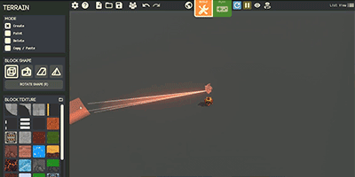

**The above gif shows how drag and drop somewhat works. (Image Source : Game Builder by Steam)**

The user can also create custom modules that already don’t exist in the module library which can be saved on the platform for his/her personal use or to trade it in the marketplace with other users. This will allow us to expand the module library beyond the traditional limitations and allow users to share their unique and creative ideas with each other allowing our platform to have high community support.

The modules that users will create will only work exclusively on our platform but the content created using them can be shared elsewhere too.